Method of Disbursement – BANK Setup: The Method of Disbursement (MOD) portion of A/P provides the ability to generate checks for more than one back account AND the ability to pay A/P invoices with a credit card. The checking accounts to be used need to be defined in BANK. This screen is used for the Bank Reconciliation and MOD. NOTE: You cannot delete a bank account or edit an account line associated with an active MOD after you have created and saved it.

To access this function, you can either:

- Select “General Ledger” from the menu and choose the “Bank Reconciliation” submenu. Click on “Bank Setup.”
- Type “BANK” in the Shortcuts Bar.

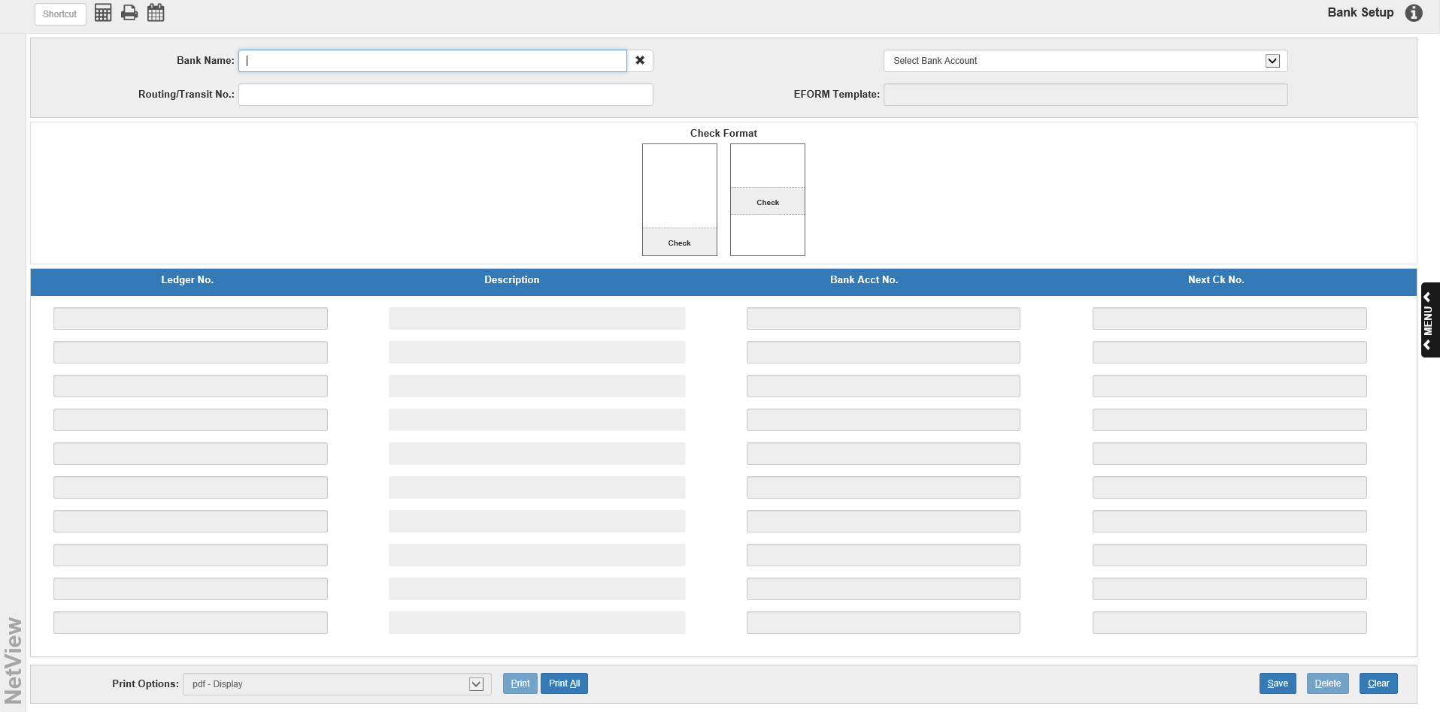

To make use of additional bank accounts for printing checks may require that you acquire pre-printed forms for the new account(s) or additional e-forms check templates. Be sure that you have these handled before proceeding with the rest of the MOD setup process.

Eforms checks: If you are going to use e-forms checks, the bank accounts to be used must be defined in BANK.

- Enter the Bank Name in the field provided.
- Fill in the Routing/Transit Number in the field provided.
- The name for the appropriate EFORM template will be provided by the system.
- Choose the check format that fits your chosen template.
- Enter or select the G/L account for this bank.
- Enter the Bank Account Number in the field provided.
- Choose a beginning check number and enter it in the space provided.
- Save the record.

Preprinted checks: If you are going to use pre-printed checks, the bank accounts to be used must be defined in BANK.

- Enter the Bank Name in the field provided.
- Enter the Routing/Transit Number in the field provided.
- The EFORM template field is not used in this case.
- Choose the check format that fits your pre-printed checks.
- Enter or select the G/L account for this bank.
- Enter the Bank Account Number in the field provided.
- Choose a beginning check number and enter it in the space provided.
- Save the record.

Credit Cards as a Method of Disbursement: If you are going to use a credit card to pay A/P invoices, the accounts to be used must be defined in BANK.

- Enter the Credit Card/Bank Name in the field provided.
- Leave the Routing/Transit Number field BLANK.
- The EFORM template field is not used in this case.
- Pick a check format.
- Enter 20000 or your A/P G/L account for this credit card/bank.
- Enter or look up the A/P Vendor Number for the credit card/bank in the field provided.
- Choose a beginning check number and enter it in the space provided.
- Save the record.

